|  |
| --- |
|  |
| **Iterative Design Report** |
|  |
|  |
| **11020070** |
|  |

|  |
| --- |
|  |

Introduction

The Healthy Eating Information System (HEIS) has been designed to help its users gain a better understanding of eating healthily. The system provides personalised information and recommendations to users based on their dietary goals and needs. It also takes into account the previous meal choices which the user had made.

The target users for this system are university students because the final product will be based in the OneZone refectory in the University of the West of England to allow student to efficiently purchase healthy meals.

This system has been created not just to enable students in making the right meal choices, but also to help them learn about eating healthy in general. The system presents a short description of the meal that the user has selected, and information regarding calories, proteins, and cost. This will also help the students become more aware of their eating choices for the future.

This report has been created to outline the iterative design process undertaken to design a high fidelity prototype of the HEIS. The report comprises of the primary and secondary research carried out to gather information for designing the system; the iterative design processes of low-fidelity, wireframe of the prototype and high-fidelity prototype.

Primary and Secondary Research

To help design the initial low-fidelity prototype, I firstly had to conduct primary and secondary research in order to understand what a typical touchscreen graphical user interface (GUI) design consists of, and which components are needed to enable users in achieving their tasks and goals effectively and efficiently whilst using the system. To do this information gathering process I paired up with three other students from class so that the information could be gathered at a much faster rate, since we had very little time.

These are the activities completed within the B2 process which I have done:

* **iPlus kiosk system review** - To get an understanding of how user interfaces are implemented within touchscreen based systems we reviewed the iPlus kiosk system based in Lawrence Hill. This review can be found in the Design Journal within the folder ‘iPlus Review’.
* **Key graphical user interface issues** - I made note of key issues raised from three credible sources which outlined design guidelines and principles. This enabled me to learn about the issues which I needed to take into consideration when designing the HEIS. The completed task can be found in the Design Journal within the folder ‘GUI Key Issues’.
* **Five inspirations –** I looked at five online applications to get inspirations for the type of contents that I will need to implement within the HEIS. For each of the applications, I listed the good and the bad features. This document can be found in the Design Journal within the folder ‘Five Inspirations’.
* **Rich Picture –** Creating the rich picture enabled me to understand who the potential target users are for the HEIS. It also allowed me to visually represent the problem domain of the HEIS, and to find out who the key stakeholders are for the HEIS. The rich picture document can be found in the Design Journal within the folder ‘Rich Picture’.
* **PACT analysis –** The PACT analysis enabled me to learn more about the target users of the HEIS; what the target users do within OneZone refectory; learn more about the context within which the HEIS will be placed in; and the technology which the target users currently use within the OneZone refectory to make their meal choices. The PACT analysis can be found in the Design Journal within the folder ‘PACT Analysis’.
* **Persona -** I conducted interviews with students from the university to generate personas of the HEIS’s target users. The persona helped me to think about the features which the system will need to allow its target users in achieving their goals. The persona document can be found in the Design Journal within the folder ‘Personas’. I combined the responses which I received from the participants into one persona because they were mostly the same.
* **Scenarios -** Scenarios enabled me to think about the tasks which the user will be performing with the system, and the steps they need to take in achieving their goal. The scenarios can be found in the Design Journal within the folder ‘Scenarios’.
* **Components -** I also created a list of components which the system will need to incorporate based on the Jeff Patton’s From User Story to User Interface PDF. This helped me to think about how the user will interact with the system based on their specific task, how the system will present information, and what components are needed to present that information. The components list can be found in the same document as the Scenarios, since the components are based on the scenarios. The scenarios can be found in the Design Journal within the folder ‘Scenarios’.
* **Requirements –** I created the requirements for the HEIS outlining the functional and non-functional requirements that are needed for the HEIS, its context, and its users. This helped me to think about the components needed for the HEIS. The list of requirements can be found in the Design Journal within the folder ‘Requirements’.
* **Hierarchical Task Analysis –** This helped to envisage the steps the user will take when carrying out the tasks generated from the scenarios. The hierarchical task analysis document can be found in the Design Journal within the folder ‘Hierarchical Task Analysis’.

Low Fidelity Iterative Design Process

Low fidelity (lo-fi) prototyping is most often used during the early stages of the design cycle. It allows the designer to create rough mockups of their mental model of the system using only paper, pen, and other stationaries. The low visual and content of the paper based prototypes might allow evaluation participants to give honest feedback to the designer because they do not see the prototype as something which the designer has worked for many hours on, and so they would be more open about its criticism.

The lo-fi iterative design process also takes less time to go through, so many cycles of the lo-fi prototype could be done in a short amount of time because of the less resources and time going into making the prototype.

The main reason why lo-fi prototyping is the most useful tool to use at an earlier stage of the iterative design process is because the designer does not have to be concerned about the colour scheme or the definitive layout of the components. The main goal of the lo-fi prototype is to find out whether if the components implemented such as buttons and text boxes enable the user to achieve their goals. The designer will only be concerned with the design presentation of the prototype during the high-fidelity design iteration process.

**Low-fidelity Design Decisions**

My main design decisions came after creating the components list by following the Jeff Patton’s worksheet. From following this worksheet I was able to create a list of abstract components which the system needed to have in order for it to allow the user to achieve their goals whilst using the system. For example, I made the design decision of including a button to enable the user to edit their calorie limit on the My Profile lo-fi page because it is needed for the user to update their calorie goals. To view the list of components which I have created from the user intentions, please open the Scenarios folder within the Design Journal.

I also made a design decision of including the functionality of showing Recommended Meals because of the persona which I had created of the system’s target user. This persona required the HEIS to suggest to them meal options whilst taking into account any dietary goals or needs they might have set. To implement this design decision, I created a page titled Recommended Meals which is designed for displaying only the user’s recommended meal option. I also created a button on the main menu to allow users to efficiently go to their recommended meals page upon logging into the system. To view the persona, please open the folder Persona in the Design Journal.

Another design decision I made was to implement a navigation bar. This decision was made because I took inspiration from the iPlus kiosk. The iPlus system incorporated a navigation bar at the bottom of its user interface. From this bar, users were able to return to the homepage, as well as access additional features of the system. For the HEIS, I decided to create a navigational bar at the top of the screen because the location is more conventional and also because it the user will be much more likely to notice it when they are in a rush. To view the iPlus kiosk review, please open the folder iPlus Review within the Design Journal.

**Initial Low-fidelity Prototype scans**

To view the initial lo-fi prototype that I created, please go to the Design Journal and open the folder ‘Initial Low-fidelity Scans’.

**Low-fidelity Evaluation Plan**

I created a lo-fi evaluation plane for the two lo-fi evaluation processes. This plan can be found in the Design Journal within a folder titled Low-fidelity Evaluation Plan.

Lo-Fi Prototype Evaluation 1

The first lo-fi evaluation process was a success which allowed me to gain feedback about the component the user required in order for them to achieve their goals whilst using the system. However, there were few issues which emerged that hindered the evaluation process, but they were not so serious as to completely stop the evaluation.

**Outcome 1 – First time use setup**

During this initial lo-fi evaluation process, one of the problems that were highlighted was that the user was unaware about setting up their dietary needs and goals when using the system for the first time.

This outcome was a usability issue related to Jakob Nielsen’s heuristic of Error Prevention because the user was not given a clear indication about setting up their dietary needs/goal. I assumed whilst designing this prototype that the user would have prior knowledge of setting up their dietary needs and goals. This issue is also highlighted within the hierarchical task analysis that I had done and within which you can see that I had not taken into account the user using the system for the first time. Please view the ‘Hierarchical Analysis’ folder within the attached Design Journal.

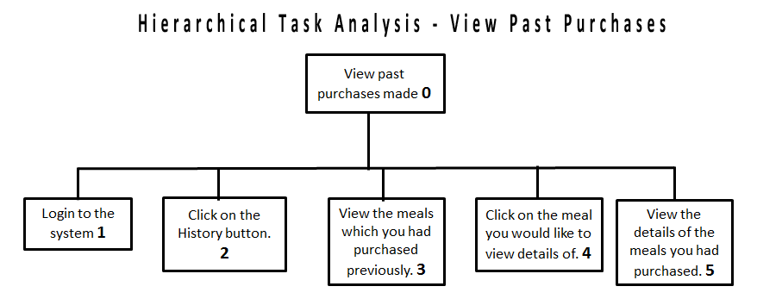

For me to address this issue, I will need to present the user a setup screen right after they log into the system. The screen will only be presented if the user has not used the system before. The set up screen will ask the user to insert any dietary needs (such as allergies) or goals for the system to use so that the most relevant meals are presented to them whilst searching for meals within the Browse Meals section.

**Outcome 2 – Support for Removing Meal Selections**

Another issue which was made apparent from the evaluation process was that the user was unable to delete/remove meals from their meal tray. This was a usability issue related to Jakob Nielsen’s User Control and Freedom heuristic because the prototype restricted the user’s options to undo their meal selection.

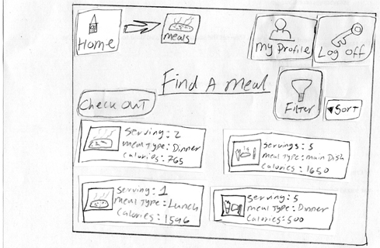

I think that this was one of the key outcomes from this evaluation process because it showed that the user had restrictions in terms of freedom and control over their interaction with the system.

This issue might have occurred because I did not have a requirement listed within the Requirements document (see folder in Design Journal named ‘Requirements’) to enable the user to remove meals from their purchasing list. This led me to design this prototype without the added functionality of removing meals.

As a result of this outcome, I will also implement a button within the My Tray screen to allow the user to delete meals from the list that is presented. The button will be placed adjacent to the meals, and so users will then have the ability to click on the button to remove a meal from the list.

**Outcome 3 – Visibility of Food Credits**

The second participant suggested that the Food Credits (money to pay for meals) should be visible to the user at all times. They suggested this because they had a difficult time remembering the food credits they had left to spend because it was placed within the My Profile screen of the prototype, and so they had to revisit that screen to remind themselves of how much Food Credits they had left.

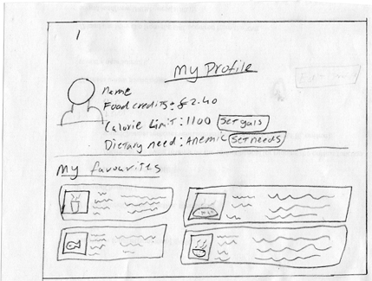

This issue relates to one of Don Norman’s Design Principle of Visibility because the Food Credits were not visible to the user at all times. The amount of Food Credits in the user’s account is an important piece of information which the user is made to search for, when in fact it should be visible to them at all times.

To address this issue, I will consider moving the Food Credits information from the My Profile screen to the top navigation bar of the system so that the Food Credits are made visible to the user at all times. This idea was taken as an inspiration from the Tesco Food application which displays the total monetary amount of all ingredients purchased by the user within its application’s top navigation bar. I looked at Tesco Food within the Five Inspiration document (see folder named ‘Five Inspiration’ within the Design Journal).

**Overall Thought on the Evaluation Process**

Overall I believe that this evaluation process was a success because I received good feedback on the prototype, allowing me to make improvements to it, ready for the second lo-fi iteration process.

One of the things which I will need to change about the evaluation plan will be the location within which I conduct the evaluation. The main issue with this was that it was too noisy, and that it was hard for me to hear the participants well, especially when it was lunch time. This might have hindered the validity of the evaluation process because with the environment being loud, I might have missed some comments from the participants.

Lo-fi Prototype Evaluation 2

From conducting the first lo-fi prototype evaluation and implementing the changes as required from the issues raised within the first evaluation process, I then conducted another prototype evaluation process of the new lo-fi prototype containing the changes mentioned in the first evaluation process.

**Outcome 1 - No Indication of Going over Calorie Limit**

One of the key outcomes that I found during this evaluation process was that participant one was not aware of whether they had gone over their target calorie limit or not. The prototype displayed their calorie limit, but did not show the total amount of calories they had within their tray (see image “FavouriteMeals” within the folder Initial Lo-fi Scan in the Design Journal). This made the participant add up the total calories in their heads for the meals they had put into their tray.

This outcome was a usability issue of Jakob Nielsen’s Visibility of System Status heuristic because the user was not kept informed about whether if they had reached their calorie limit or not after purchasing meals.

To address this issue I will need to implement a visual indicator which presents to the user the total amount of calories added up from all the meals within My Tray. This feature will be implemented within all the screens of the prototype which allow users to select meals because users will need to be informed about reaching their calorie limit whilst they are selecting meals.

To minimise the possibilities of the user not viewing the calorie limit counter on the Browse Meals and My Tray screen, the calorie limit indicator will need to be placed near the purchase button. This is because the user will need to click on the Purchase button to purchase the meals, and so if the calorie counter is close to it then there is more chance of the user viewing it.

**Outcome 2 - Remove User’s Favourite Meals from My Profile**

One of the things which I noticed from the evaluation process with the first participant was that the user’s favourite meals are displayed within the My Profile and My Favourites screens of the prototype (see image “MyProfile” within the folder Initial Lo-fi Scans in the Design Journal). This would result in vital screen space being taken up by information which is redundant and which the user could access from another source within the prototype.

This outcome is a usability issue of Jakob Nielson’s Aesthetic and Minimalist Design heuristic not only because one type of information is presented on two different screens, but also because My Profile screen contains other pieces information within it, such as the user’s calorie goals and dietary needs. This means that the visibility of all the information within that screen is diminished because every piece of information is competing for the user’s attention.

To address this issue, I have decided to remove the user’s favourite meals list from My Profile screen mainly because the user will not intuitively go to My Profile to view their favourite meals since the user is presented with a large button on the main menu to allow them to view their favourite meals.

**Final thoughts on the evaluation process**

I thought that the evaluation process went well and that both the participants were engaged in their tasks. They felt comfortable with doing the evaluation from start to finish, and offered good advice for the prototype.

One of the things which I would do differently next time would be to more active and ask the participants more questions about the reasons why they decided to choose the options that they did within the prototype. This is so that I am able to understand the participant and their reasoning behind their choices. Since the participants are also representative of the target users of the HEIS, it further benefits me to get as much feedback from them as possible since then I would be able to apply that feedback in designing the HEIS to be more usable for the target users.

Wireframe Prototype Process

Creating a wireframe design of the user interface is an important phase in the iterative design process. Wireframes enable the designer to represent the layout design of the user interface, visually displaying the page structure and navigational scheme. Although they do not contain any finished design elements, they do allow for the designer to envisage where elements such as buttons, images, and text will appear on the page.

One of the advantages of wireframe design is that changes to it can be made more efficiently and cheaply allowing the designer to fine-tune the wireframe layout until they are content with the result. If the designer did not use wireframes and went straight for high-fidelity design, then making those changes to the user interface would not be cost effective and would take considerable amount of time to implement and re-evaluate.

The main benefit of creating and evaluating a wireframe design of the system’s user interface is that it allows for the designer to see how easy or difficult it is for a user to navigate through the system to achieve their goals. If the user has a difficult time navigating through the system, then not only will they find the experience of using the system unsatisfactory, but also they will be reluctant to use the system in the future. This is one of the reasons why a wireframe design phase is important, so that the designer can find out if the user is able to intuitively navigate through their system.

**The Initial Wireframes**

To view the initial wireframes for the HEIS which I created, please go to the Design Journal and open the folder named ‘Wireframe Version 1’.

**Wireframe Evaluation Plan**

I created an evaluation plane for the wireframe evaluation. This plan can be found in the Design Journal within a folder titled Wireframe Evaluation Plan.

Wireframe Evaluation Process 1

**Outcome 1 – No Allergen Information Presented**

During the second participant during the first task made me aware by querying why the meal’s screen did not show the list of allergens contained within the meal. This was because I had forgotten to include that information within the wireframes whilst I was creating them.

Without providing the allergen information within the meal’s screen, it caused a usability issue of Don Norman’s Design principle of Visibility. This was because the relevant allergen information was not displayed to the user, which would have caused serious health issues for them if they were allergic to a particular ingredient within the meal that they might have purchased.

To address this issue, I will need to insert the allergen information within all the meals page so that the user is made aware of what allergens are contained within the meal. The placement of this information will need to be close to the meal so that the user is more likely to be able to see the information.

**Outcome 2 – Too Many Meals Displayed**

Another outcome which I found was that the second participant thought that there were too many meal selections presented within the Search Meals screen. Within this wireframe screen I am displaying six meal boxes all of which containing text and images to represent the meals (see image “mealsearch” from the folder Wireframes Version 1 in the Design Journal). This might have caused the participant to be overwhelmed by the information which is displayed to them.

This outcome is a usability issue of Jakob Nielsen’s Aesthetic and Minimalist Design heuristic because the wireframe displays six boxes all of which containing images and texts which compete for the user’s attention, and therefore the user is overwhelmed by the amount of information that is presented.

To address this issue, I will reduce the amount of meals that are shown on the Search Meals screen from six to four. This will create enough white space around the meal elements so that users do not feel like they are being presented with too much information. It will also allow for the other elements on the screen such as the purchase button and the calorie limit counter to also come forward and be more noticeable by the user.

**Overall Thought on the Evaluation Process**

In my opinion, I felt that the evaluation process with the first participant was a bit rushed. This might have been because we were conducting the evaluation process within their own home and that they did not seem engaged in the whole evaluation process. One of the reasons why this might have been could be because they might have felt the wireframes to be unengaging because of barren design in terms of visuals and colour.

I felt that I conducted my role as the evaluator well because I was probing the participants about their navigational choices and their thoughts on the layout of the wireframes. One of the things which I would do differently for the next evaluation processes would be to be more prompt in showing the wireframes to the participants. The delay in showing the participants the next screen might have made them irritated because it took time for me to find the correct page.

High-fidelity Prototyping

High-fidelity (hi-fi) prototyping is an important stage in the iterative design process. Hi-fi prototypes enable the designer to create interactive prototypes which resemble the final system for the user to test and give their opinion on.

However, creating a hi-fi prototype requires specialist software to allow the designer to create mockups which represent the design of the final system. This means that the designer will need to be familiar with using hi-fi prototyping software to create the prototypes because some of them require high learnability.

Creating hi-fi prototype is also time-consuming because the designer has to implement visuals, textual, and interactive elements within the prototype. For a business this would cost a lot of money because time is invested in creating the prototypes.

However, if any flaws or problems with the functionality and/or the design of the prototype are discovered during the hi-fi prototyping stage - would mean that the problems could be acted upon and fixed before the final product is developed. This might reduce the cost of the final system because the problems were discovered during the hi-fi prototyping stage before the final system is developed.

**High-Fidelity Design Decisions**

One of the first design decisions I made was to present large buttons on the main menu to represent the different features of the HEIS. This design decision was made after taking into consideration one of the key points I found from Source 1 within the Key Design Guidelines and Principles document (see GUI Key Issues folder in the Design Journal). The key point which I took into consideration from Source 1 stated that “make the target size larger than the visible UI element. This would reinforce accuracy of the system”. Since the user interface which I am designing is for a touchscreen, accuracy is very important in making the system usable, which is why I took the design decision of making the buttons larger than normal on the main menu.

Another design decision I made was to visually depict the amount of calories and proteins contained within a meal. I made this design decision based on one of the good points I found from the Vineo application which I looked at within the Five Inspirations document (see folder titled Five Inspirations in the Design Journal). I made this design decision because visual depiction of information is very important when considering efficiency of the system because users will be able to take in information far quicker than having to read a sentence, therefore representing calories and proteins as visuals will help increase the efficiency of the user using the system.

I also made the design decision of using icons near texts to reinforce the functionality of buttons in the minds of the users. This design decision was made after taking into consideration one of the key points from Source 2 of the Key Design Guidelines and Principles document (see GUI Key Issues folder in the Design Journal). This will enable the users to identify the functionality of the button much more quickly because they will be able recognise the icon associated with the button, and thus also remembering the functionality of the button.

A design decision was made to also use neutral and contrasting colours throughout the prototype. This design decision was made in regards to the persona created of the target user who is colour blind (see Persona folder in the Design Journal), and also because of the accessibility requirements stating that the hi-fi prototype should be in contrasting colours (see Requirements folder in the Design Journal). Having contrasting colours will enable people who are colour blind to view the different components of the prototype. However care must be taken so that the colours are not too contrasting which would cause people who are not colour blind to experience fatigue in their eyes.

**Initial High-fidelity Prototype**

You can view the screenshots of the initial high-fidelity prototype within the folder ‘Initial High-fidelity’ in the Design Journal folder.

**Limitations with Software**

For designing the hi-fi prototype I had a choice between two software - Balsamiq and Axure. They both have their advantages and disadvantages, however I chose to use Balsamiq mainly because it is much more user friendly and easier to learn than Axure which has a high learning curve.

Nevertheless, the limitations with Balsamiq were that firstly it does not contain buttons with active states (upon mouse down). This meant that when a user clicks down on a button (to simulate a user pressing down the button with their finger) within the hi-fi prototype, the button’s state did not change and they are given no feedback to tell them that they have clicked the button.

Another limitation with Balsamiq is that it is unable to set variables upon certain events happening. For example, within the hi-fi prototype I wanted the food credits to change upon the user going through the top-up process; however Balsamiq was unable to do that because of it lacked the functionality to set variables upon certain events happening.

If I had used Axure, then I would have been able to add more functionality to the hi-fi prototype, however I would have needed to invest a lot of time in learning to use it, which was not the case with Balsamiq.

**High-fidelity Evaluation Plan**

I created an evaluation plane for the high-fidelity evaluation process. This plan can be found in the Design Journal within a folder titled “High-fidelity Evaluation Plan”.

High-fidelity Evaluation Process 1

**Outcome 1 – Not Enough Food Credits Message**

From doing the first hi-fi evaluation process, I was able to discover that I needed to notify the user about them not having enough Food Credits to purchase a meal. This was discovered when the second participant wanted to add a meal to their tray which they could not afford.

This was a usability issue of Jakob Nielsen’s Visibility of System Status heuristic because the participant was not made aware of the system status of them not having enough Food Credits to purchase that meal.

Instead of the prototype not allowing them to add the meal to the tray, it should display a message to the user to notify them that they do not have enough Food Credits. This will make them aware of the system status of not having enough Food Credits by displaying a message next to the price of the meal telling the users that they do not have enough Food Credits. This will also increase efficiency of use for the system because the user does not have to attempt to add the meal to the tray and then the message being shown. The message will be shown as soon as the user enters the meal’s page.

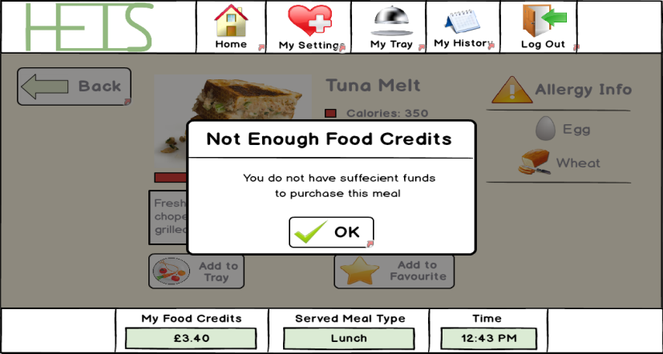

**Outcome 2 – Top-up only on the Main Menu**

Another outcome which I found was that the first participant thought of it being long winded in having to go to the main menu to access the top-up screen. This was because the top-up screen is currently only accessible via the main menu screen.

This was a usability issue of Jakob Nielsen’s Flexibility and Efficiency of Use heuristic because the top-up button is only accessible via the main menu. Having the top-up button only on the main menu decreases the efficiency with which the user will use the system because they will need to go to the main menu every time to access the top-up screen.

For me to address this issue, I will add a link to the top-up screen within the top navigation of the system. This way the user will be able to access the top-up screen from anywhere in the HEIS. This will reinforce the user’s effeciency because it takes out an extra step for them to access the top-up menu.

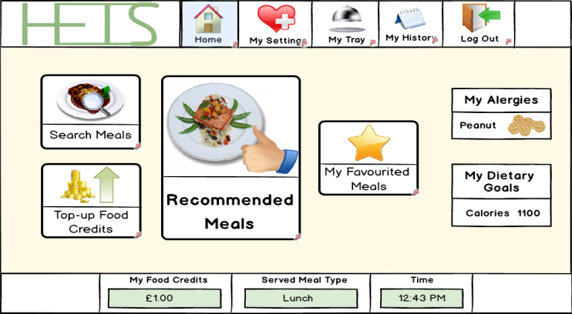

**Outcome 3 – Page Titles**

It was also discovered that participant 2 found it difficult to tell which type of meals page they were on, such as My Favourites, Search Meals or Recommended Meals. This was because the title of the page was placed near the top right hand side of the screen, which the user might have had trouble noticing because it was not displayed to them straight on.

This caused a usability issue of Jakob Nielsen’s Visibility of System Status heuristic because the prototype did not make it visibly clear to the user which type of meal page they were on because of the title of the page not being in the center of the screen.

To address this issue, I will need to place the title of the screen to the center, and move the buttons which are currently in the center to the right. This will make it apparent to the user which screen they are on upon entering.

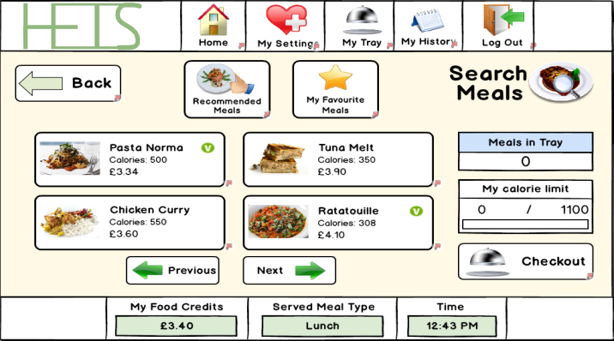

**Final Thoughts on the Evaluation Process**

I believe that this evaluation process went better than expected since this evaluation process was conducted using a computer to simulate the prototype, whereas I used paper prototypes on the previous evaluations.

Since this evaluation process was done using a laptop, I felt that I was able to write down more notes, and the participants able to give clear and concise feedback because I did not have to present them with a paper representation of the prototype screens, meaning that my hands were free to write down notes.

I also thought that the evaluation went well because the prototype contained visuals and colour to engage the participants more, whereas there was no colour or graphics within the previous lo-fi and wireframe prototypes. The high visual quality of the prototype might have made the participants more serious about doing the tasks because they saw the effort I put into making the prototype.

However, the participants could also be less forward about their criticism on the prototype because they might not want to hurt my feelings, after seeing the effort I put into making the prototype. This would make the evaluation process less reliable because the participants might not give their honest feedback.

One of the things which I should do for the next evaluation process would be to tell the participants before starting the evaluation process to be open about their criticism of the prototype. The evaluation process would be of no benefit for me if I am unable to get honest opinions from the system’s target users.

High-fidelity Evaluation Process 2

**Issue 1 - No Price of Meal on Final Confirm Message**

Participant 2 was able to make me aware of the fact that the confirmation message that is displayed to the user when they are about to purchase all the meals within their tray did not contain the total cost of the all meals. They also pointed out that the Successful Purchase screen also did not show the cost of all the meals that the user might have purchased.

This was a usability issue of Jakob Nielsen’s Error Prevention heuristic because by not displaying the total cost of all the meals which the user is about to purchase, the user could unknowingly purchase expensive meals if they are in a rush.

Even though the prototype shows the user the total cost of all the meal that they are about to purchase within the My Tray screen, the total cost should also be added within the final confirmation message which is displayed to the user when they press the Purchase button. This will reduce the error of the user unknowingly purchasing expensive meals if they are in a rush.

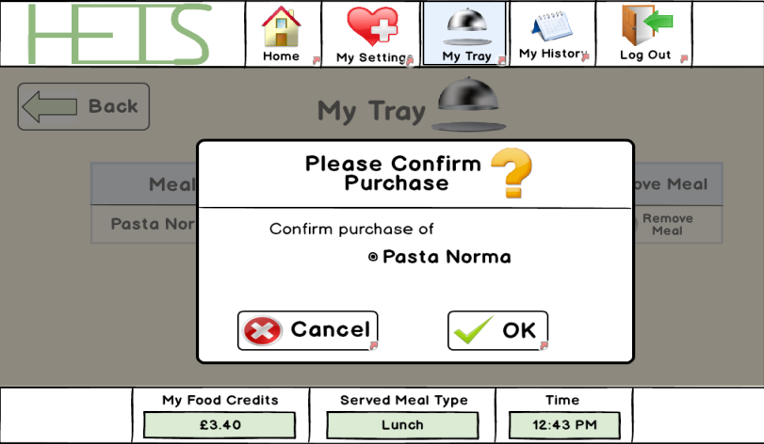

**Issue 2 - Favourite Meals not Clearly Displayed**

During this evaluation process, participant 1 noticed that the Add To Favourites button was displayed on the meals which the user had already favourited. This would lead the user into mistakenly thinking that they have not favourited the meal.

This outcome was a usability issue of Jakob Nielsen’s Visibility of System Status heuristic because the system has not made the user aware of the fact that they have already favourited the meal. There should be an appropriate message either next to the meal on the Search Meals screen; or the Add to favourite button should be removed from the meal’s screen altogether and replaced with a button to allow the user to unfavourite the meal.

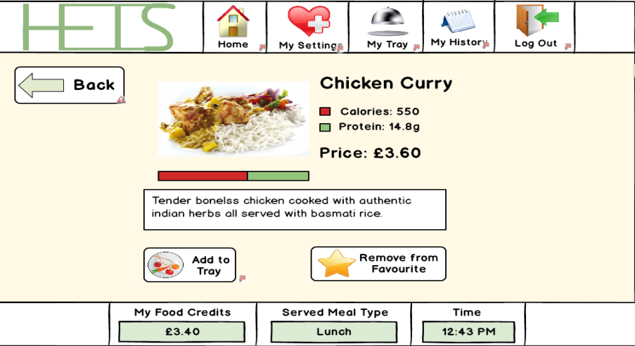

**Final Thoughts on the Evaluation Process**

Like other evaluations which were conducted in the participant’ own home, this evaluation process also went well. This might have been because both the participants felt comfortable in the environment of their own home. However, it would have been much more beneficial if the evaluation could have been conducted within the OneZone so that the prototype could have been used in an environment which the final product will be placed in.

However, conducting the evaluation in a home environment there is a high chance of a distraction occurring, and this evaluation was no exception process. During the evaluation process with the first participant, one of the distractions we had was with their mother entering and leaving the living room. This distracted the participant from their task which would have skewed the reliability of the evaluation process.

**Final High-fidelity screenshots**

You can view the screenshots of the final high-fidelity prototype within the folder titled ‘Final High-fidelity Screenshots’ within the Design Journal folder.